Inquiry Demonstration Plan
Lesson Title: | Photosynthesis and cellular respiration | Lesson # | 3, 4 & 5 | Date: | 2020-07-31
Name: | Rajmanpreet Kaur | Subject(s): | Science | Grade(s): | 8

Rationale & Overview

It is important to have scientific knowledge of the chemical process that occurred in photosynthesis to satisfy the curiosity of the students that how plants are alive and feed and its importance in life. Students can evident a photosynthesis process through a video and can experiment through lab activity to view the chloroplast in leaves. Thus, they will learn how to do a lab experiment.
Students would share their observations and results of experiments with the potted plants to identify the important resources for plants and ask questions they developed through brainstorming. It would help to teach and learn how to analyze/interpret data collected. It includes asking, investigate, and create, which are the components of the inquiry cycle and would be followed by the explanation of the process and procedure from teacher and video demonstration. Last would be the lab activity to examine the chloroplast in leaves. Students would be given some time to reflect on the whole lesson by giving a journal on this in the next class.

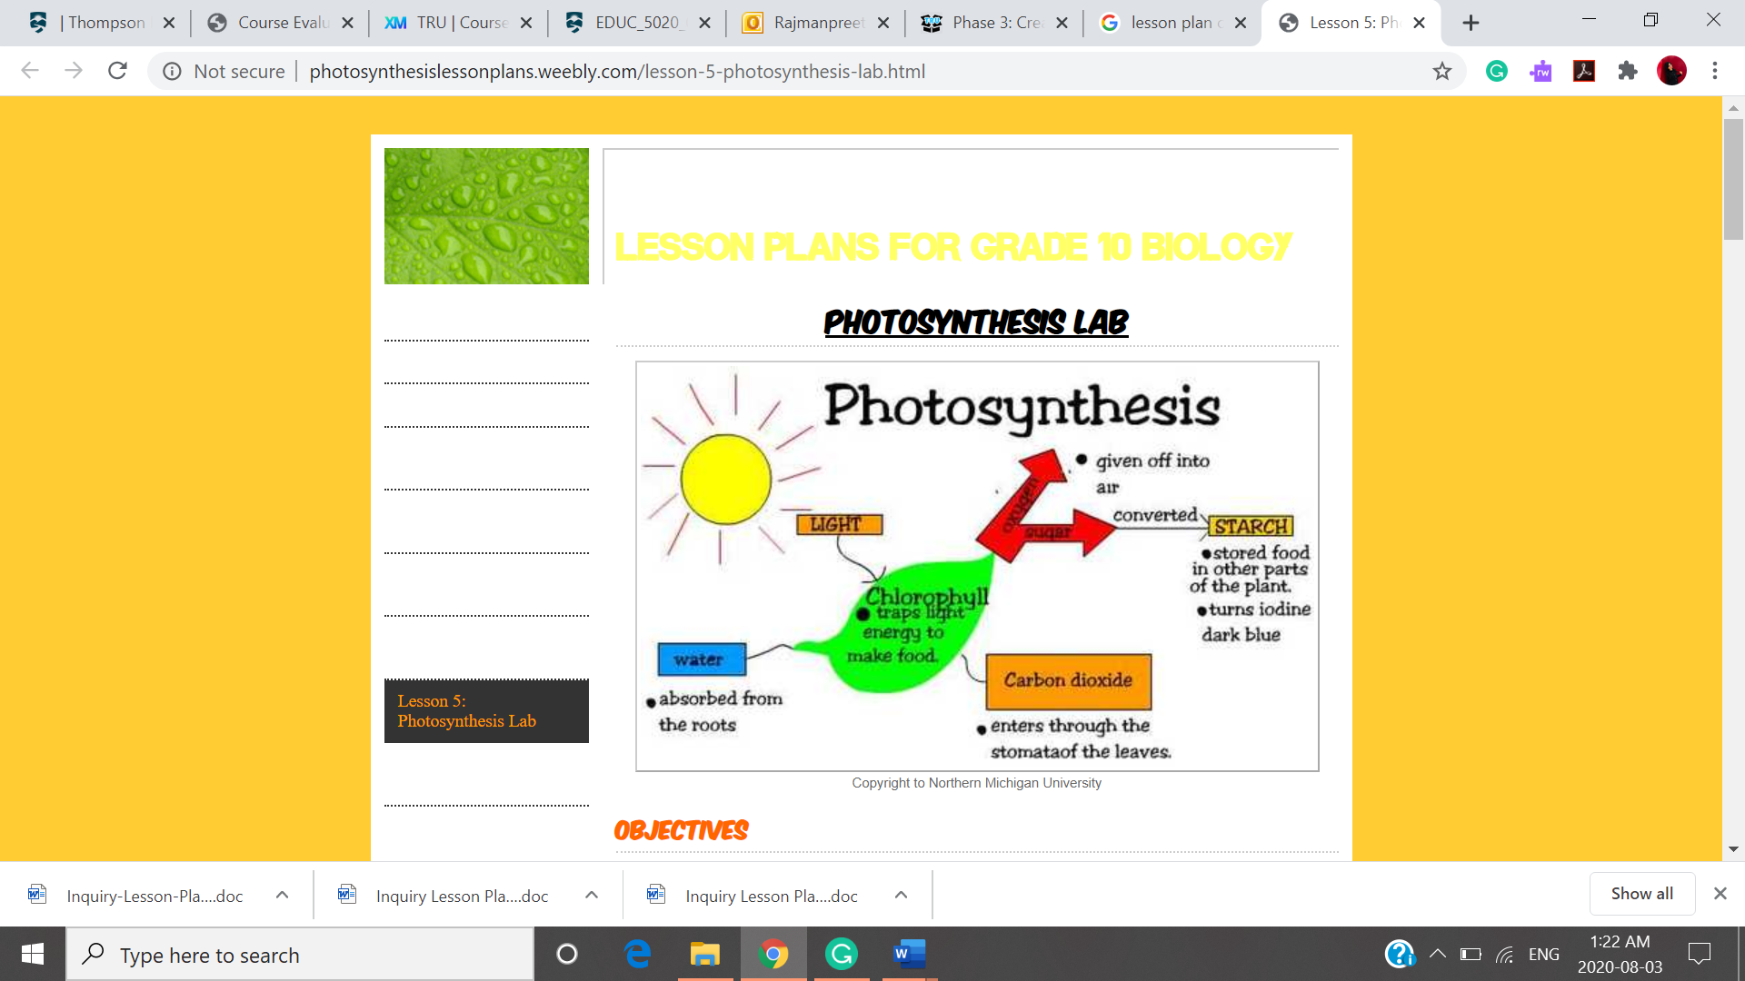
Key Questions For Inquiry

Core Question & Supporting Questions for Inquiry Project | Question(s) Addressed in This Lesson
Explain the overall reaction of photosynthesis.  What is the role of chloroplast in this reaction and carbon dioxide?  Explain the role of sunlight and water.  Explain the light-independent reaction.  What is a dark reaction in plants? | How does a tree grow?  What do you think plants need to grow? why?  What is photosynthesis?  How does this chemical reaction occur?  Describe the interdependence of living organisms on plants.  What happens when there is no sunlight?  Discuss the interrelation between cellular respiration and photosynthesis.
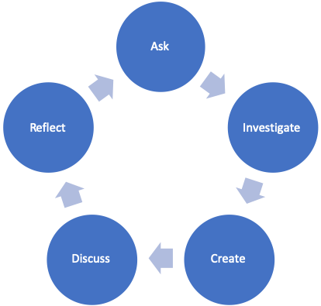

Inquiry Approach and Rationale

Learns would come to know that plants produce oxygen through photosynthesis, and other organisms like humans and animals depend on them for oxygen. Thus, they will start valuing more plants.

Core Principles of Effective Teaching (Sharon Friesen) Focus on one or more core principles in the lesson

Core Principle 1: Effective teaching practice begins with the thoughtful and intentional design of learning that engages students intellectually and academically.  *What aspects of the inquiry are the most challenging and meaningful for students? | To make hypotheses based on their observations and measurements could be tough for many students who are not scientists by birth and are disinterested in studying science. However, when they will realize their interdependence for living on plants. It can encourage them to participate well.
Core Principle 2: The work that students are asked to undertake is worthy of their time and attention, is personally relevant, and deeply connected to the world in which they live.  *What makes this inquiry valuable, meaningful, and “alive” for the students and teachers? | This would make them realize the importance of plants in their lives which would make it personally relevant and worthy of their time. As a result, they will start valuing plants.
Core Principle 3: Assessment practices are clearly focused on improving student learning and guiding teaching decisions and actions.  *How do I define learning and success in this inquiry? How is learning expressed and articulated in peer, self, and teacher assessments? | The assessment would be done holistically based on their participation, enthusiasm, and how they form connections with life for deeper understanding.
Core Principle 4: Teachers foster a variety of interdependent relationships in classrooms that promote learning and create a strong culture around learning.  *How do I connect students with each other, with experts in the field, with larger communities and nature, and across disciplines? | Students would be worked in pre-decided groups, which would inculcate teamwork, leadership, and communication skills.
Core Principle 5: Teachers improve their practice in the company of peers.  *How do I reflect on the inquiry together, and/or collaborate with others? | The teacher would get an idea from the performance of the students in submitted journals that what she missed, what was most challenging for my students, and next time these issues can be overcome by working proactively.

BC Curriculum Core Competencies

Communication | Thinking | Personal & Social
Working in small groups. | Observation, investigation, creation of hypothesis, and participation in lesson and lab activity, would help students to engage intellectually and academically. | Learners will start valuing plants; their attitude would reflect in the suggestions made to save plants in the next class.

BC Curriculum Big Ideas (STUDENTS UNDERSTAND)

Students will understand
Photosynthesis and cellular respiration.
The Interdependence of humans on plants for living

BC Curriculum Learning Standards

(STUDENTS DO) | (STUDENTS KNOW)
Learning Standards - Curricular Competencies | Learning Standards - Content
Students would make observations, measurements, and notice minor changes in plant color, shape, and size.  Students will perform a lab activity to identify starch.  Students will write a journal at the end of the class to reflect their understanding. | Photosynthesis  Light reaction  Dark rection  Cellular respiration  The interdependence of human on plants for living

BC Curriculum Indigenous Connections/ First Peoples Principles of Learning

Students would be encouraged to share their views and traditional knowledge about how plants feed and are alive. Those can be associated with the spiritual knowledge of indigenous people regarding plants like how they worship plants before harvesting, how they consider plants equivalent to humans who also feel pain.

Respectful Relations

Students would be encouraged to share their knowledge regarding how plants feed and human interdependence on plants, it may include their cultural or traditional values or knowledge of plants. It would be entirely optional; they would not be forced to do so. The use of technology would also be encouraged to demonstrate the chemical process in the form of simulations. Students would be supported by providing all the needed resources and help if needed. The use of gender-neutral terms would encourage and preferred in the classroom. Students would be allowed to share any kind of misconception or superstitions related to plants.

Lesson Activities

Lesson 3
Time Allotted |  | Teacher | Students
Invitation | 05 minutes | Agenda for today’s class | Listen well, and do the necessary preparations
Inquiry | 10-15 minutes | Questions and hypotheses from students would be expected. | Students would share what they inquired and observed by giving their hypothesis.
Discussion | 30-35 minutes | The teacher would explain photosynthesis- light-dependent reaction | Students would acquire scientific knowledge
Reflection | Homework | Homework would be given to reflect on the whole scientific knowledge students acquired | Students would submit their journal in next class
Lesson 4
Time Allotted |  | Teacher | Students
Invitation | 10-15 minutes | Agenda would be discussed; previous learning and understanding would be recalled | Students would share their journals in small groups
Inquiry | 05-10 minutes | New questions and hypothesis would be taken from the students | Students would present their sense of wonder on scenarios like what happens when there is no light (dark reaction)
Discussion | 15-20 minutes | An explanation and video would be used to demonstrate the dark reaction | Students would listen, ask questions, and acquire knowledge to satisfy their quest for knowing more
Reflection | Homework | Instructions would be given to write a journal | Students would submit their journal in the next class
Lesson 5 (Lab activity to identify chloroplast in plants)
Time Allotted |  | Teacher | Students
Invitation | 10-15 minutes | Students would be given instructions, material, and procedure in groups  An explanation and video would be used to demonstrate the dark reaction | Students would be expected to follow all the instructions and procedure  Students would listen, ask questions, and acquire knowledge to satisfy their quest for knowing more like what happens when there is no light (dark reaction
Inquiry | 20-25 minutes | Students would be observed and guided where needed | Students would follow all the instructions to complete the activity and reach the result in groups
Discussion | 10-15 minutes | The teacher would encourage students to share their experiences. | Students would share their understanding and experience
Reflection | Homework | Instructions would be given to write a journal | Students would submit their journal in next class

Materials and Resources

Lab material and procedure
PowerPoint including youtube videos

https://www.youtube.com/watch?v=UPBMG5EYydo&t=47s (photosynthesis- light reaction)
https://www.youtube.com/watch?v=j6Le0S52wt0 (function of sunlight light)
https://www.youtube.com/watch?v=zpdRsAv7ltM (Function of co2)
https://www.youtube.com/watch?v=c2ZTumtpHrs (The Calvin Cycle)
https://www.youtube.com/watch?v=c8wA_0pfBu8 (function of chloroplast function)

Students would be expected to have all the observed data and measurements like on changed color of leaves, height, and count of leaves.
They will be expected to come in class with their created hypothesis based on previous lessons and observations.

Organizational Strategies

Listening circles to share journals, in small as well as big groups, activities would be performed in small groups to support challenged students. Journals would be given every time to reflect on and for a deeper understanding of the content

Proactive, Positive Classroom Learning Environment Strategies

Anticipated challenges would be tackled in advance, the teacher would be in touch with students through emails in case of the need for resources or information, students would be supported in all means.

Extensions
Students would be encouraged to think upon what would happen if plant destruction would be continued like this, what can be consequences and alternatives to overcome it. What they can do?

